## ONLINE SHOPPING SYSTEM A PROJECT REPORT

***In partial fulfilment for the award of the degree***

***Of***

## CERTIFICATE IN DATA ENTRY AND WORDPROCESSING IN COMPUTER SCIENCE AND ENGINEERING



### Under the guidance of Submitted by

**Jatinder pal Singh Tashu garg (1911002)**

### Assistant Professor Ravneet Kaur(1911009) CSE Department

**SANT LONGOWAL INSTITUTE OF ENGINEERING AND TECHNOLOGY, LONGOWAL – 148106, DISTRICT- SANGRUR, PUNJAB, INDIA**

### May, 2022

Table of Contents

* Certificate 3
* Acknowledgement 4
* Abstract 5
* List of Tables 6
* List of Figures 6

Chapter 1. Introduction 7

Chapter 2. Problem Definition 8

Chapter 3. Objectives 9

Chapter 4. Methodology Used 10

Chapter 5. Results and Screenshots 16

Chapter 6. Conclusion and Future Scope 28

References

## CERTIFICATE

Certified that this project report **“ONLINE SHOPPING WEBSITE"** submitted by **Tashu Garg (1911002) and Ravneet Kaur(1911009)** in the partial fulfilment of the requirement for the award of Diploma in Integrated Certificate Diploma (ICD) under the guidance of our guide(Mr.Jatinderpal Singh).

This report has not been submitted to any other University or Institution for the award of any diploma.

TASHU GARG (CDE/1911002)

RAVNEET KAUR (CDE/1911OO9)

This is to certify that the above statement made by the candidate (s) is correct to the best of my knowledge.

Signature of Project Guide Mr. Jatinder pal Singh (Assistant Professor,CSE)

The Diploma of ICD viva-voce examination of Tashu garg and Ravneet Kaur is held on

### ACKNOWLEDGEMENT

First and foremost, we would like to express our gratitude to our guide Mr. Jatinder pal Singh(Assistant Professor, CSE) & other faculty members for giving us a wonderful opportunity to work on project. We are very thankful to him who was always ready to lend their helping hand to me.

This project has helped us in giving exposure to some of very interesting features of "Online shopping System" along beyond doubt it will help us un the short and long run .We are very grate to him introducing us to some of very exciting features of "Online shopping System". We would also like to express our gratitude to Dr.Manoj Kumar Sachan (Head of Department,CSE).

Finally, we would like to say that us indeed to my parents for everything that they have done for me. All of this would have been impossible without their constant support. And I also thanks to God for being kind to me and driving me through this journey.

## ABSTRACT

The project describes Online shopping of Electronics System. This report will help you to know in the deep the actual work that has been done as a team work. The main objective of this website is that as this project aimed at creating a virtual shop environment for users, in some handy form, which will be available to them through internet.

It helps buying the products in the shop anywhere through internet by using an android device.

Since the application is available in the Smartphone it is easily accessible and always available.

They need to maintain hundreds of thousands of records. Also searching should be very faster, so they can find required details instantly. Main objective is to create a system which helps them to complete their work faster in simple way .

**LIST OF TABLES**

* Database table
* Admin table
* brand table
* Cart table
* Category table
* Compare table
* Contact table
* Customer table
* Order table
* Wishlist table
* Product table

**LIST OF FIGURES**

Er- diagram /DFD diagram

# Chapter 1

**Introduction**

Our project contains website of power bank so we are creating a power bank and phone website so that the customer can buy power bank and phones from this website.

It is easier to search and buy products from our website rather than searching on other electronic products website because it contains only limited things ,so it is easier to get power bank and phones.

Online shopping is the process whereby consumers directly buy goods or services from a seller in real-time, without an intermediary service, over the Internet.

It is a form of electronic commerce. Thus, the customer will get the service of online shopping and home delivery from his favorite shop

**Chapter 2**

**Problem Definition:**

This project aims to develop an online shopping for customers with the goal so that it is very easy to shop your loved things from extensive number of online shopping sites available on the web. With the help of this you can carry out an online shopping from your home. Here is no compelling reason to go to the crowed stores or shopping centers during festival seasons. You simply require a PC or a laptop .To get to this online shopping system all the customers will need to have an email and password to login and proceed your shopping .

The login credentials for an online shopping system are under high security and nobody will have the capacity to crack it easily. Upon successful login the customers can purchase a wide range of things such as mobiles, books, apparel, jewellery, infant care, gifts, tools, etc. can be dispatched using online shopping system. Not just these, you can also purchase from outside nations by few clicks on your mouse. And of course, you will get your requested ordered items at your door step. It is simple. You will pick your favourite items from variety of online shopping sites looking at cost and quality. No need to go physical shops with this you will have more time to spend with your family. Almost a wide range of things can be brought through online shopping system .It is extremely secure. Customer service is accessible.

**Objective**

# Chapter 3

* This project aimed at creating a virtual shop environment for users, in some handy form, which will be available to them through internet.
* Currently , there is no any website of power bank so we are creating a power bank website so that the customer can buy power bank from this website.
* This website allows the customers to maintain their cart for add or remove the product over internet.
* The problem is that in this Pandemic everyone is going through a lot and every professional needs to be go through online for their works. Due to power consumption of mobiles, we think everybody needs it like in studies (in online mode it is very helpful to them to regain power of their device ), tourist people’s needs it, business person .

The user can access this site anywhere, he just needs the internet connection. This application includes other features also like

* To provide the security Low cost
* Free delivery of your order.
* Available for 24*7 hours.

# Chapter 4

## Methodology Used

### Front End:

* + HTML –It is used to generate web page. HTML, an initial of Hypertext Markup Language, is the predominant markup language for web pages. It provides a means to describe the structure of text-based information in a document — by denoting certain text as headings, paragraphs, lists, and so on.
  + JAVASCRIPT –JavaScript is a scripting language most often used for client-side web development. It is a dynamic, weakly typed, prototype-based language with first-class functions.
  + CSS: It stands for Cascading Style Sheets.CSS describes how HTML elements are to be displayed on screen, paper, or in other media CSS saves a lot of work. It can control the layout of multiple web pages all at once. External stylesheets are stored in CSS files

### Backend:

* + PHP:-PHP is a technology that lets you mix regular, static HTML with dynamically-generated HTML. Many Web pages that are built by CGI programs are mostly static, with the dynamic part limited to a few small locations. But most CGI variations, including servlets, make you generate the entire page via your program, even though most of it is always the same.
  + IIS SERVER /WAMP- Apache is a web container, or application server developed at the Apache Software Foundation (ASF).It adds tools for configuration and management but can also be configured by editing configuration files that are normally XML-formatted. Apache includes its own internal HTTP server
  + MySQL: It is the world's second most widely used open-source relational database management system (RDBMS). The SQL phrase stands for Structured Query Language. An application software called Navicat was used to design the tables in MySQL.

### Hardware Requirements

**Hardware Configuration:**

Processor : Intel Core i3 Processor RAM : 4 GB DDR4 RAM

Hard Disk Drive: 20 GB HDD

### Software Requirements

**Software Configuration:**

Operating System : Window 10 Web server : Xaamp server

Web Browser : Internet Explorer5.0 , Google Chrome , Microsoft Edge Designing Tool : PhpMyAdmin, HTML

### TABLES

**DATABASE TABLE**

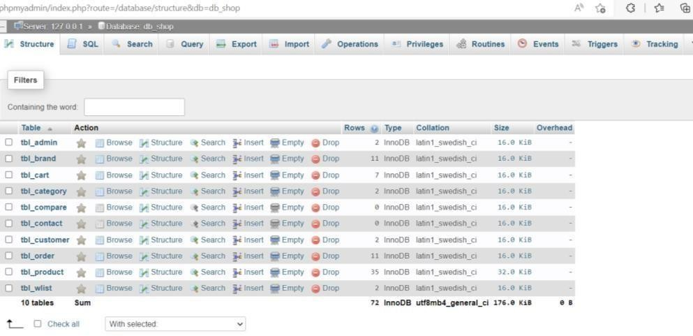

**ADMIN TABLE**

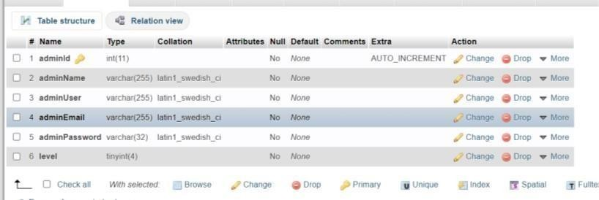

BRAND TABLE

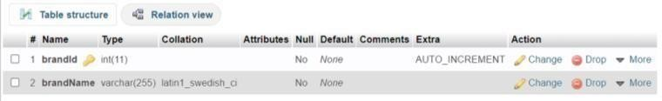

CART TABLE

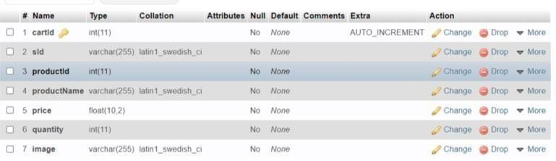

CATEGORY TABLE

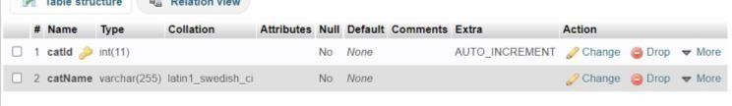

COMPARE TABLE

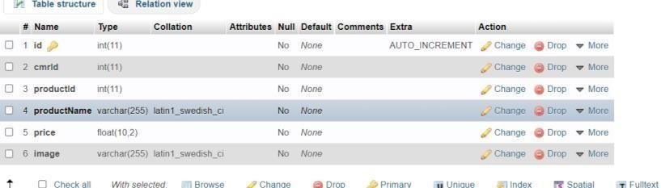

CONTACT TABLE

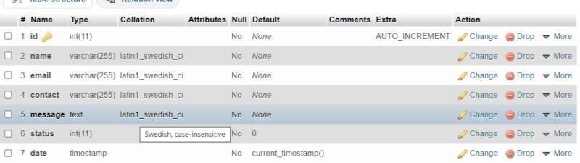

CUSTOMER/USER TABLE

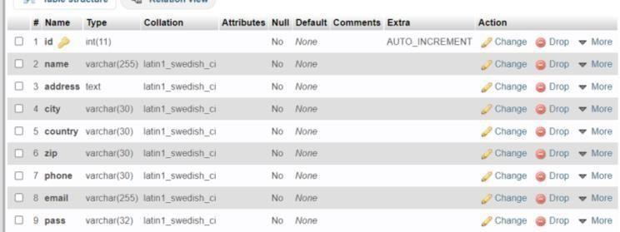

ORDER TABLE

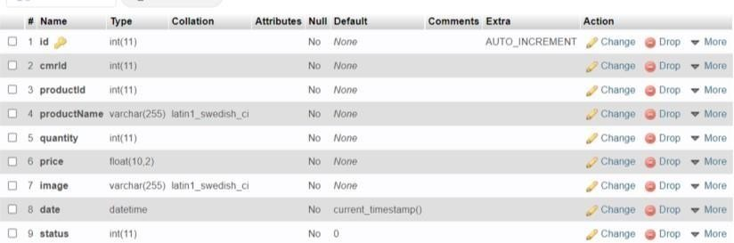

PRODUCT TABLE

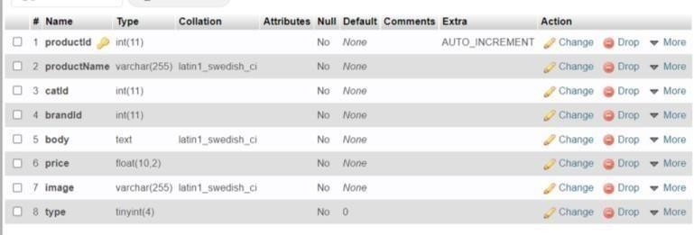

WISHLIST TABLE

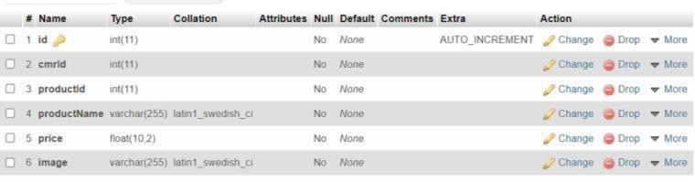

ER DIAGRAMS

**ADMINISTRATOR END USER END**

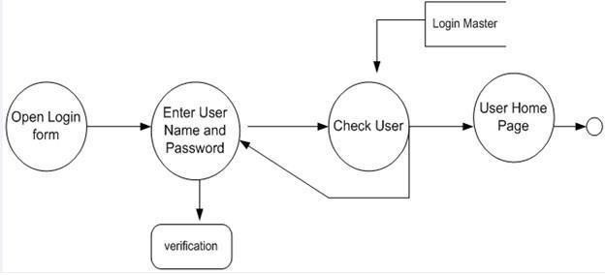

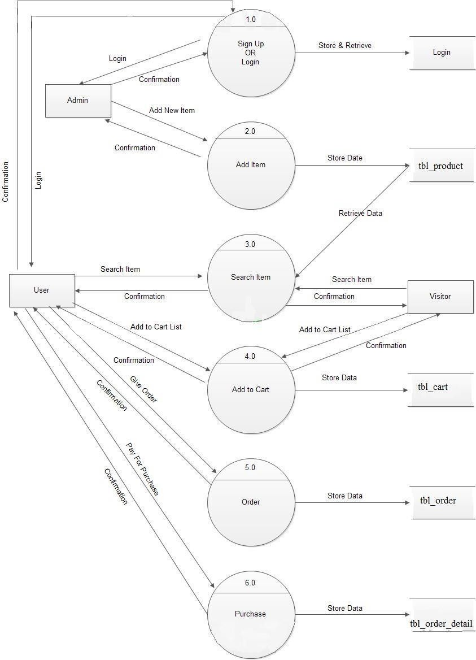

**Frontpage:**

## Chapter 5 Results and Screenshots

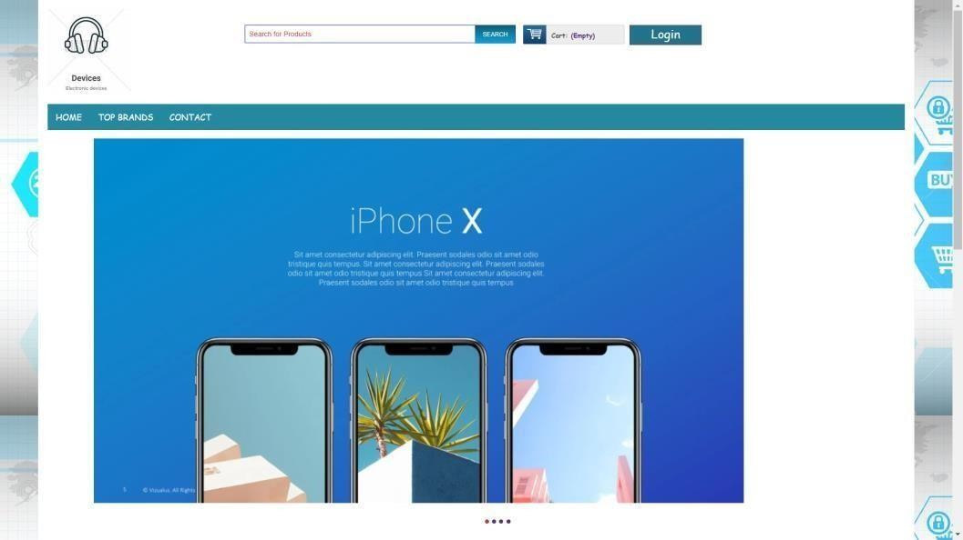

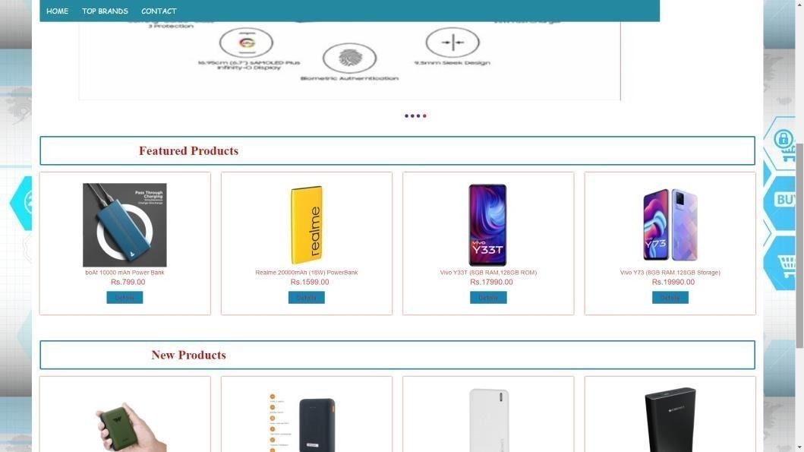

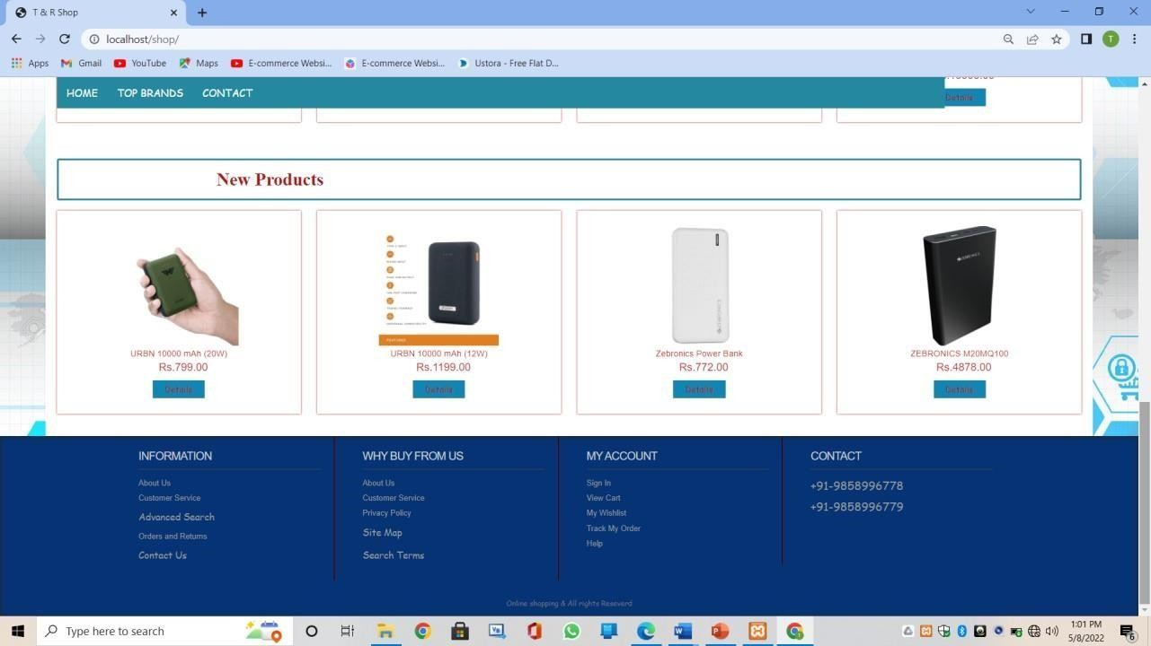

**Login page:**

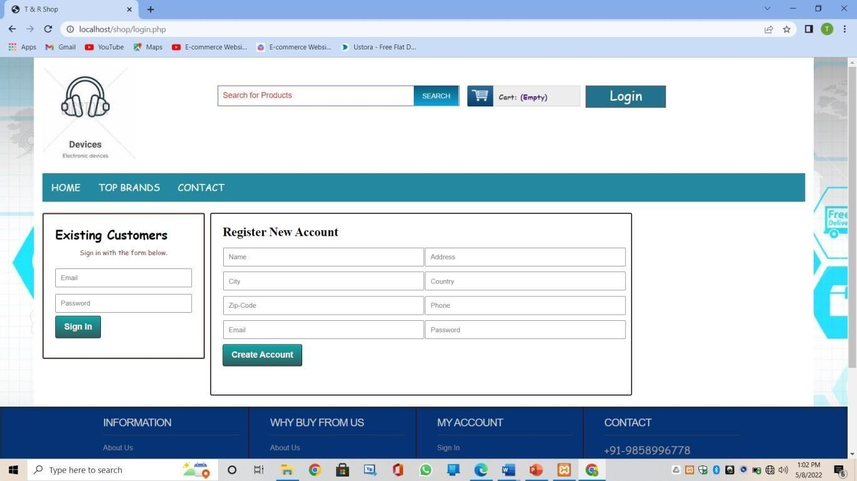

**Top brands**

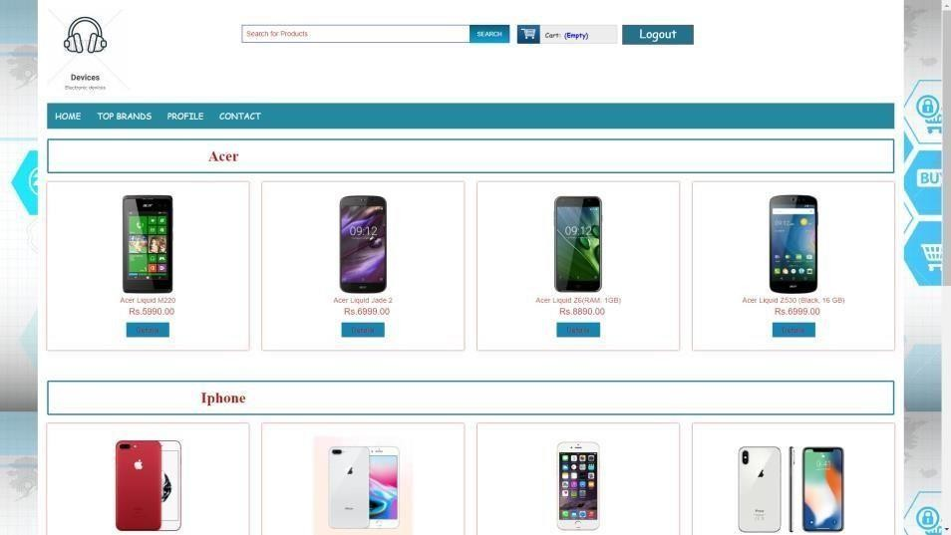

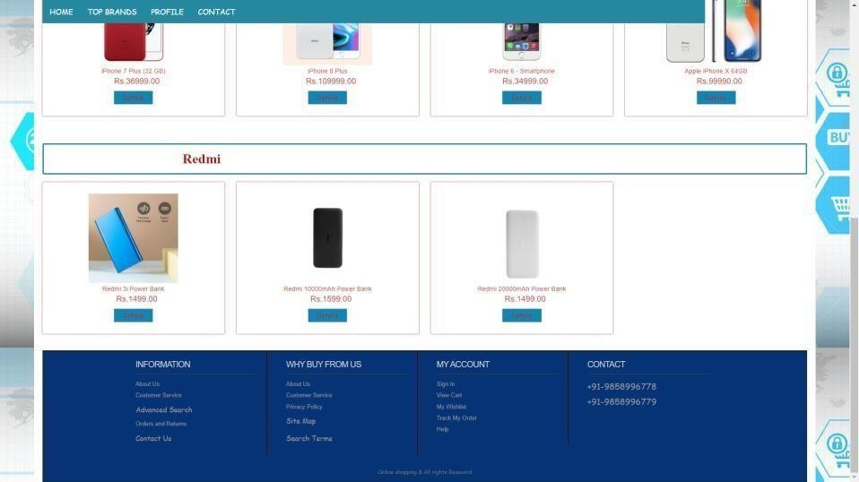

**About product:**

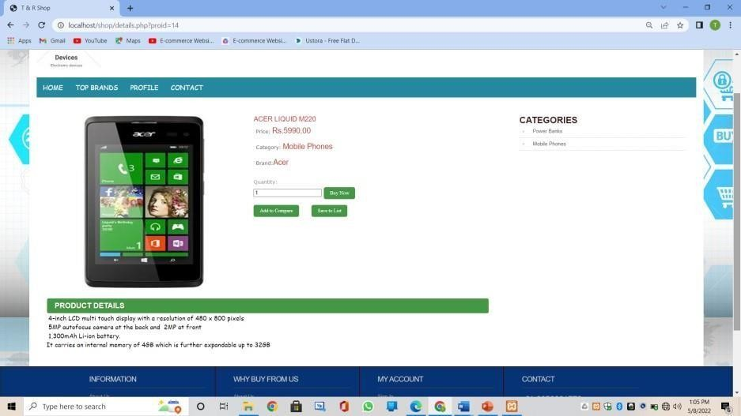

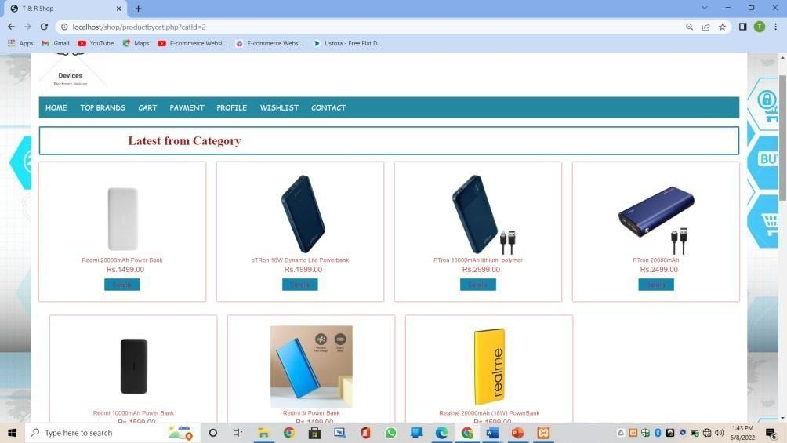**Category Power bank:**

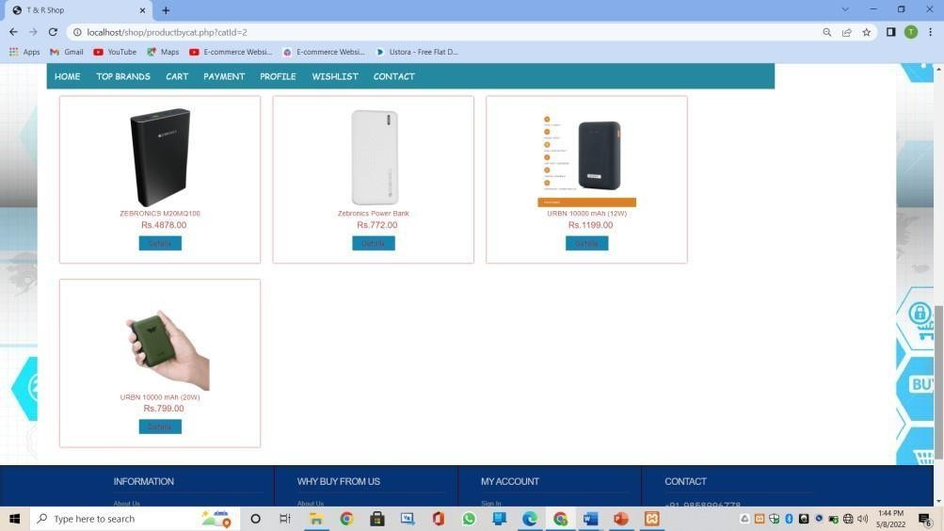

**Moblie phones:**

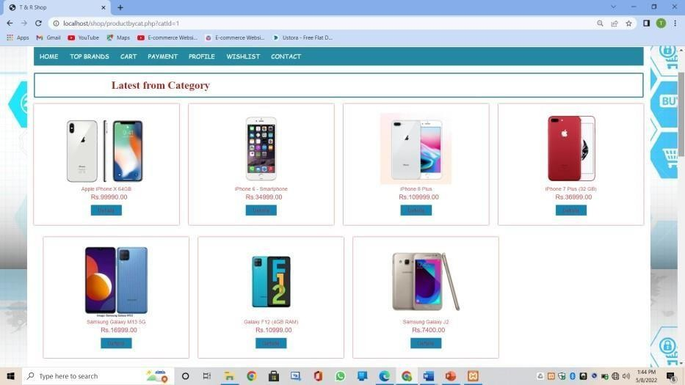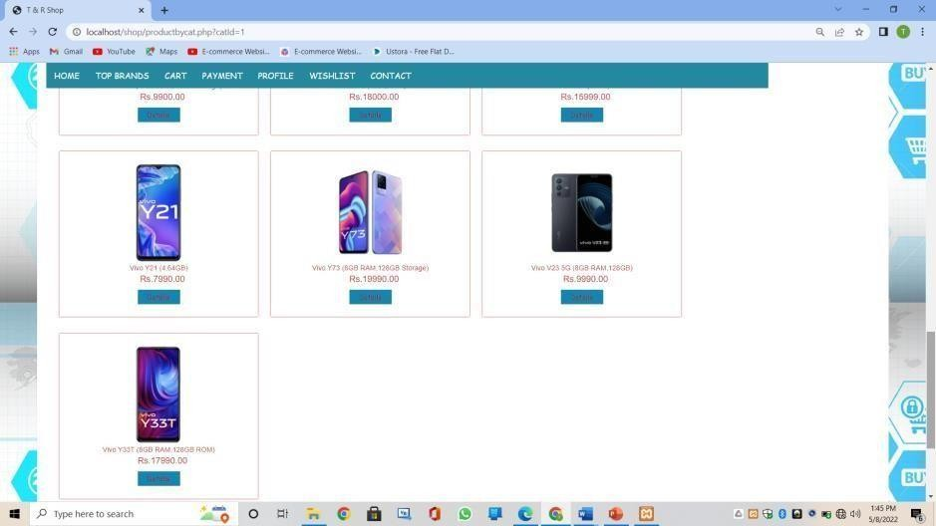

**Cart page:**

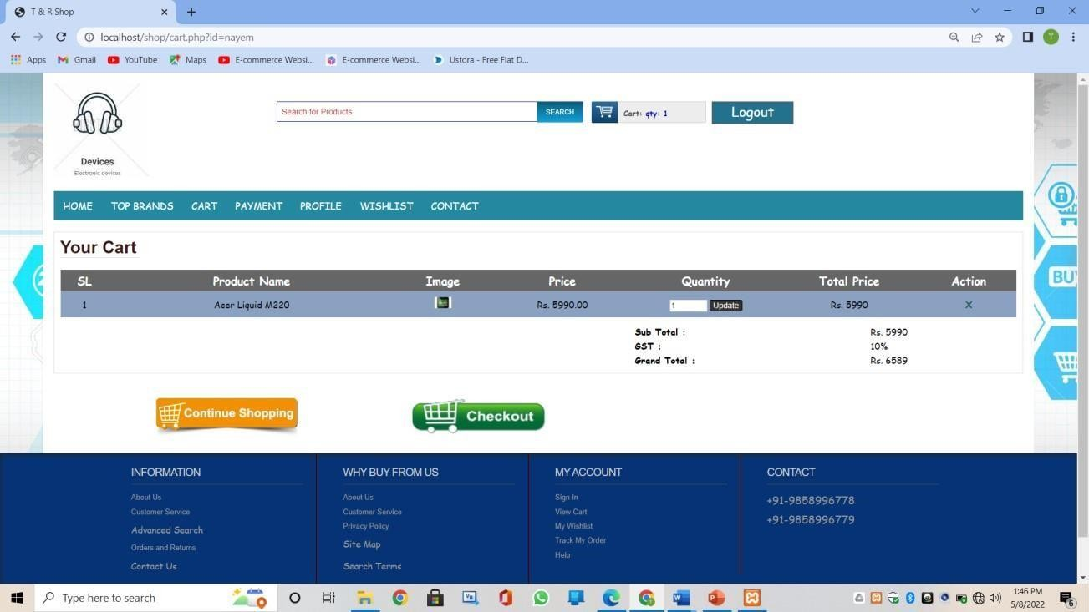

**Payment page:**

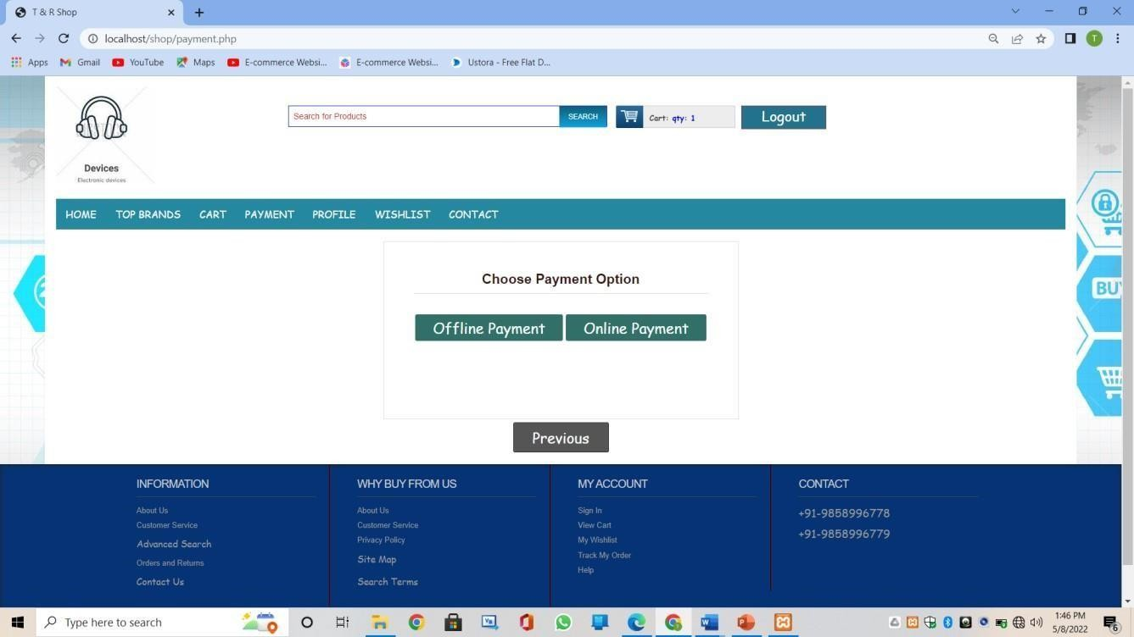

**Wishlist page:**

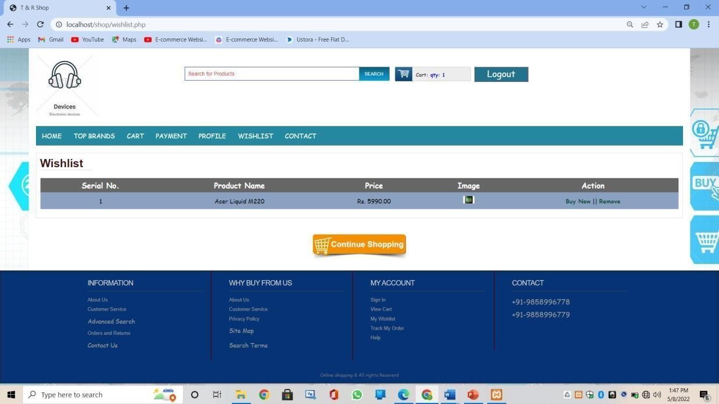

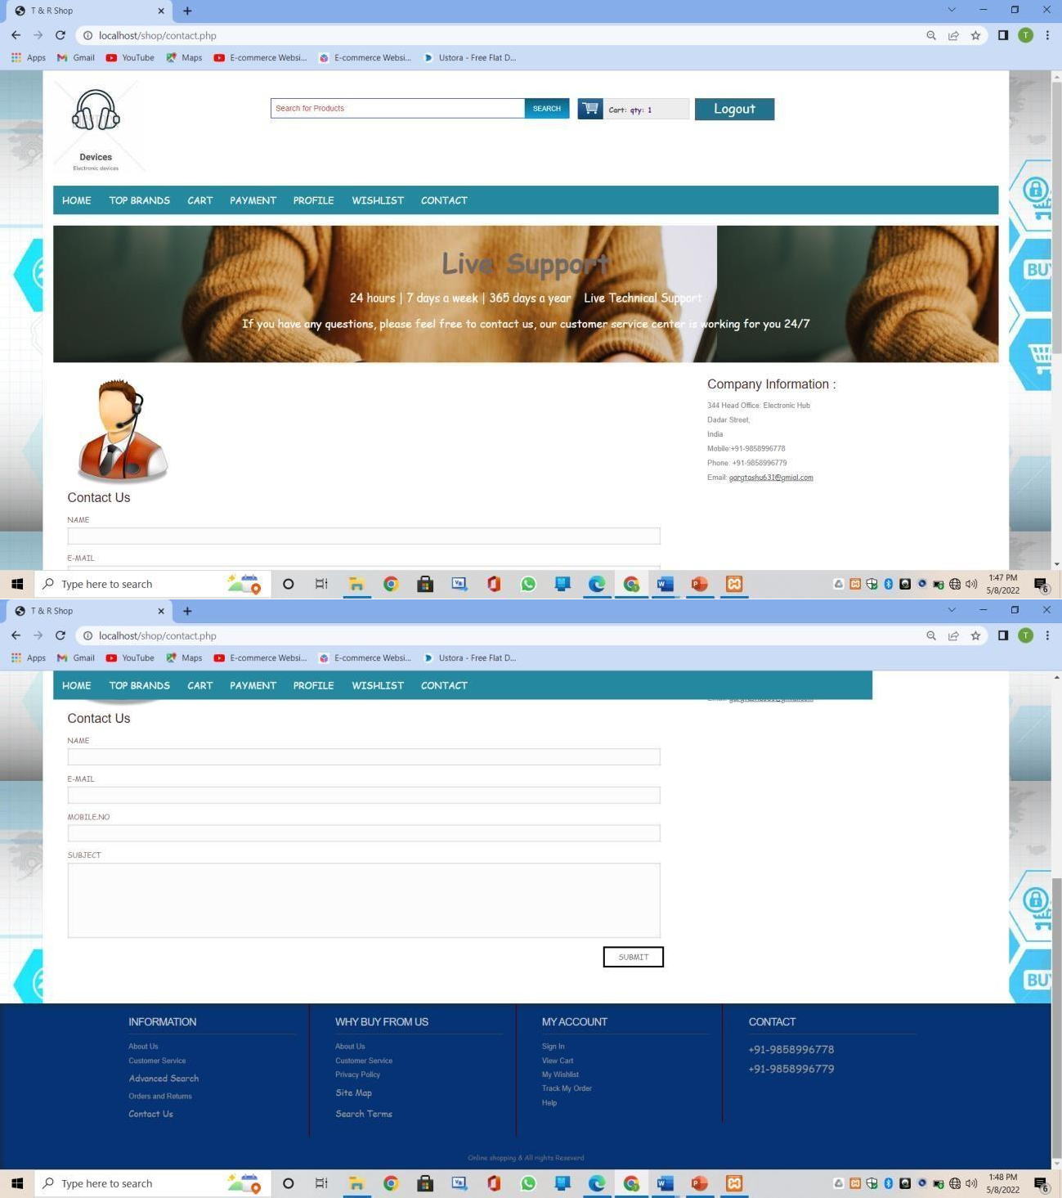**Contact page:**

**Admin login page:**

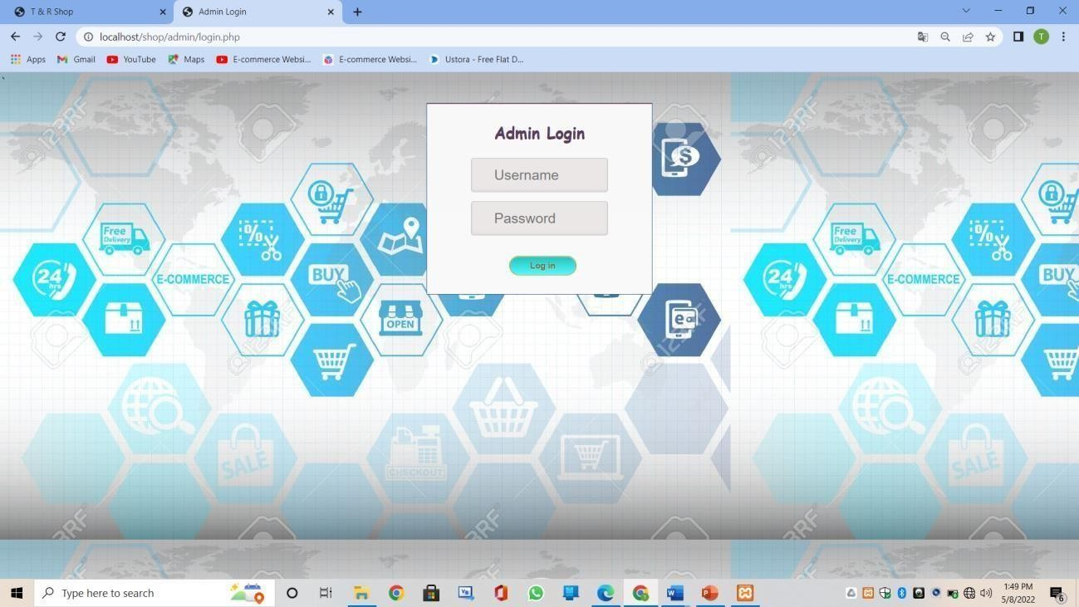

**Admin home page:**

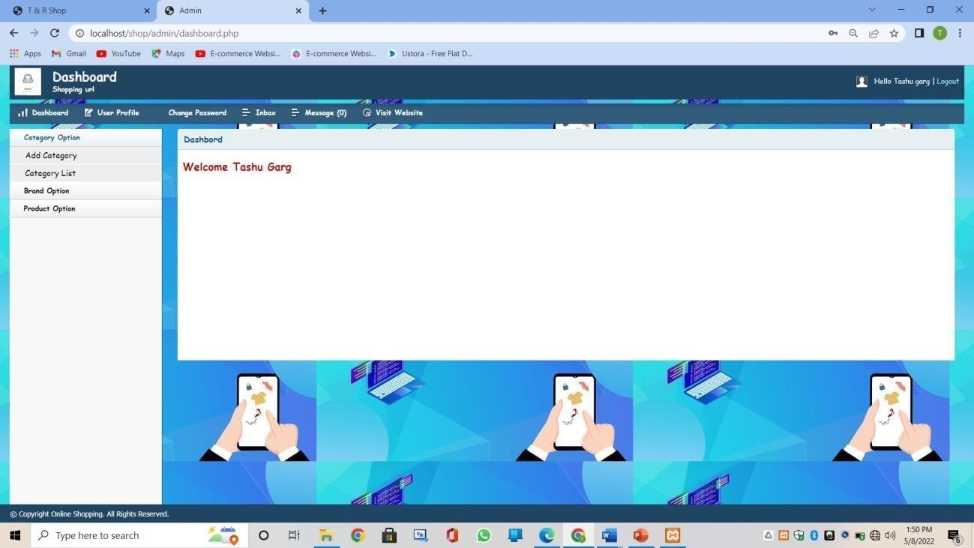

**Category page:**

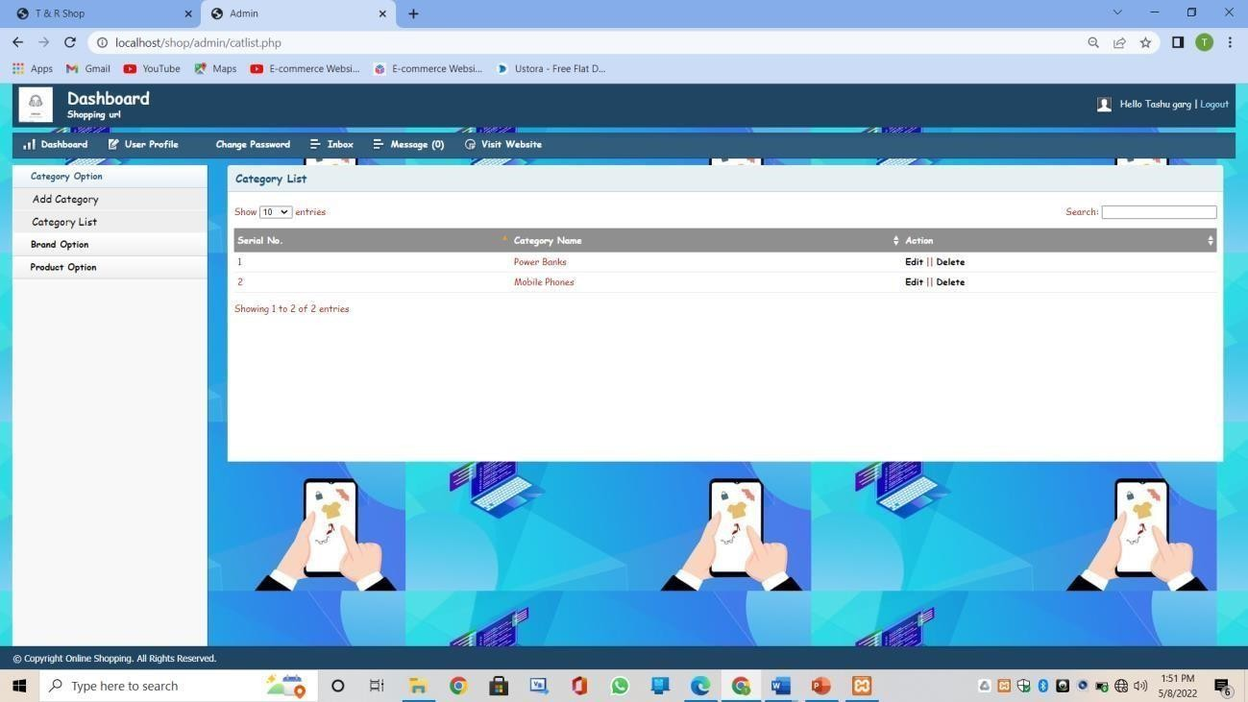

**Brand details:**

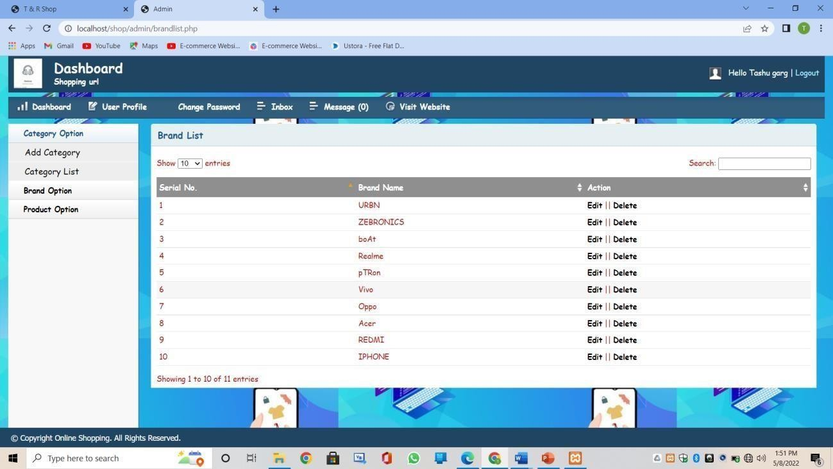

**Product list:**

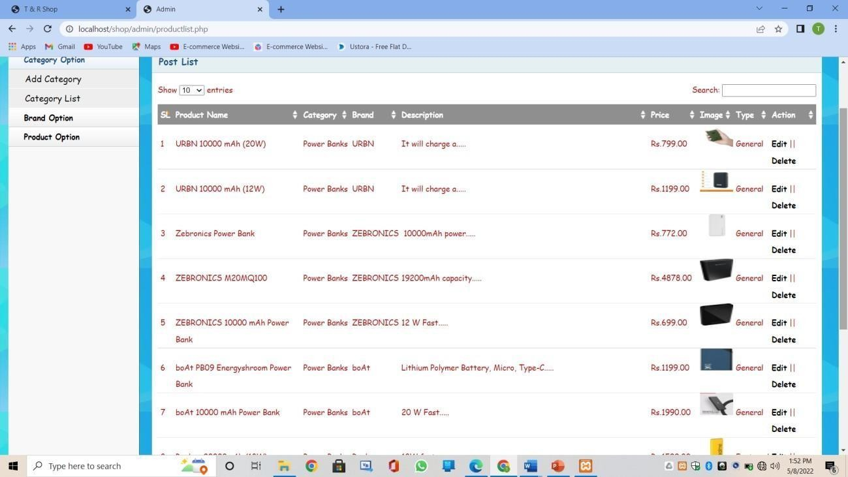

**User Message page:**

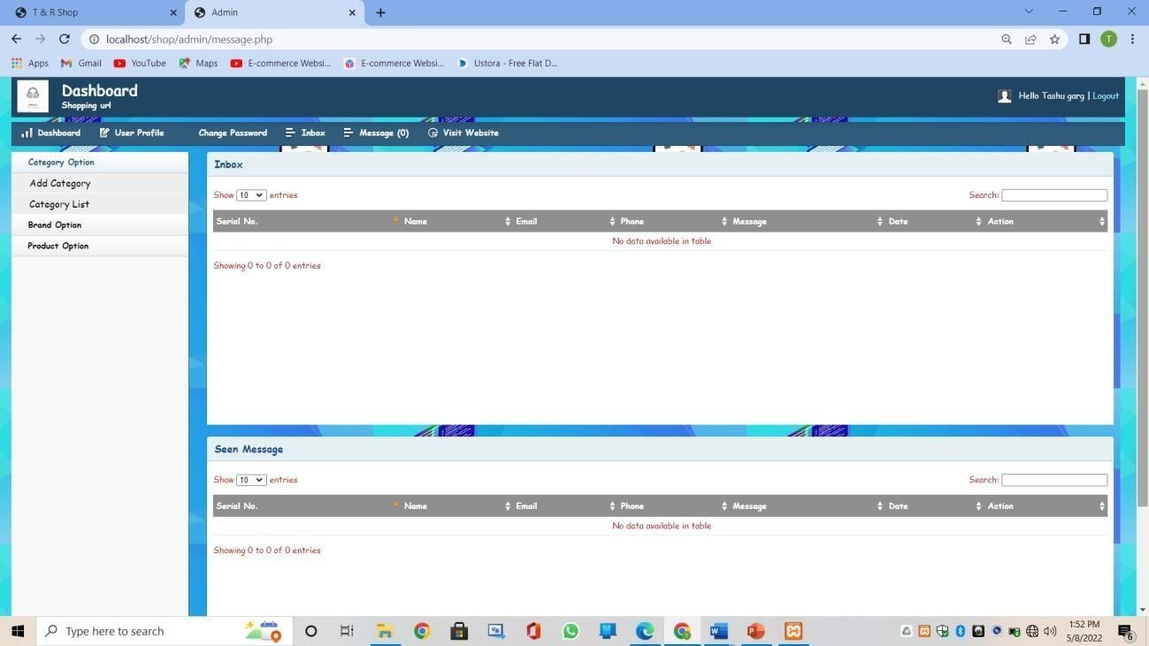

**Inbox:**

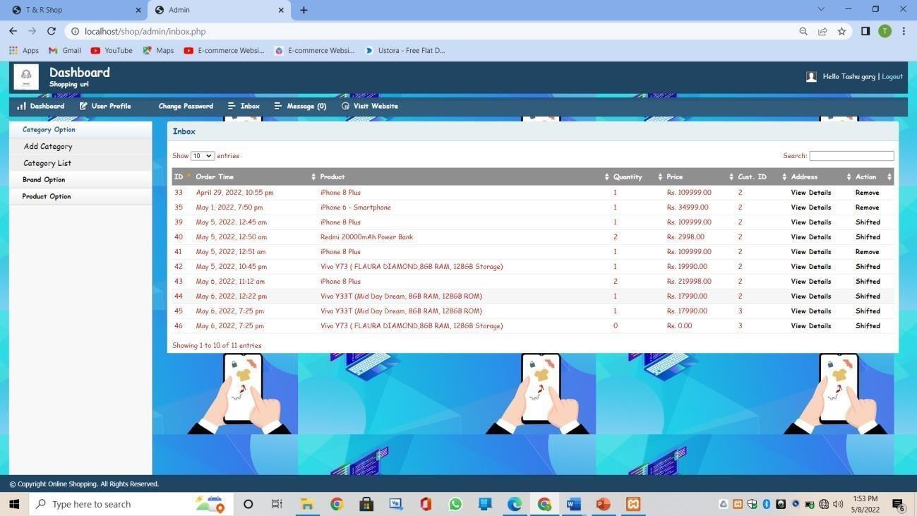

## Chapter 6 Conclusion and Future Scope :

The project entitled **Online shopping system** was completed successfully.

The system has been developed with much care and free of errors and at the same time it is efficient and less time consuming. The purpose of this project was to develop a web application and an android application for purchasing items from a shop.

This project helped us in gaining valuable information and practical knowledge on several topics like designing web pages using html & css, usage of responsive templates, designing of android applications, and management of database using MySQL . The entire system is secured. Also, the project helped us understanding about the development phases of a project and software development life cycle. We learned how to test different features of a project.

This project has given us great satisfaction in having designed an application which can be implemented to any nearby shops or branded shops selling various kinds of products by simple modifications.

There is a scope for further development in our project to a great extent. A number of features can be added to this system in future like providing moderator more control over products so that each moderator can maintain their own products. Another feature we wished to implement was providing classes for customers so that different offers can be given to each class. System may keep track of history of purchases of each customer and provide suggestions based on their history. These features could have implemented unless the time did not limit us.

### REFERENCES

1. JavaScript Enlightenment, Cody Lindley-First Edition, based on JavaScript 1.5, ECMA-262,

Edition

1. Mc Graw Hill’s , Java : The complete reference 7thEdition, Herbert Scheldt
2. Complete CSS Guide ,Maxine Sherri and John Allsopp-O'Reilly Media; September 2012
3. [http://www.w3schools.com/html/defualt.asp,](http://www.w3schools.com/html/defualt.asp) [http://www.w3schools.com/css/default.asp,](http://www.w3schools.com/css/default.asp) [http://www.w3schools.com/js/default.asp,](http://www.w3schools.com/js/default.asp) <http://www.w3schools.com/php/default.asp> <http://www.w3schools.com/mySql/default.asp>